Reporters’ Handbook
A Quick Guide to the
ABC’s of Good Journalism

1. What Is News?
News is essentially new information or current events. It is reported by newspapers, television and radio programs, web sites, and wire services. Most news is investigated and presented by journalists (or reporters).

News categories include hard news (more serious and timely topics), soft news (usually lighter topics), breaking news (most immediate), news analysis, and investigative reporting.

Types of articles include:

Local news focuses on what's going on in your community. Example: An article on a city council meeting.

National news looks at what's happening in the United States. Example: An article on the U.S. Senate passing a new bill.

International news examines news that's happening outside the United States. Example: A story on an influenza outbreak in Chile.

Feature articles often cover lighter, or soft, news topics. A feature may be a profile of a person, a cultural trend, a place, and other topics. Feature articles are not considered news stories.

Opinion or commentary contains the writer's opinion, usually backed by facts and other information. Opinion articles often focus on current events but are not considered news stories.

Reviews are essays or articles that give a critical evaluation of a book, play, film, musical recording, performance, or other art form. Reviews are not considered news stories.

2. What Is Newsworthy?

When a dog bites a man, that is not news….But if a man bites a dog, that is news.
—John B. Bogart (1845–1921), city editor of the New York Sun

Many things happen in a day. Editors and reporters must decide what belongs in the news. To be newsworthy, a news story should contain some of the following elements:
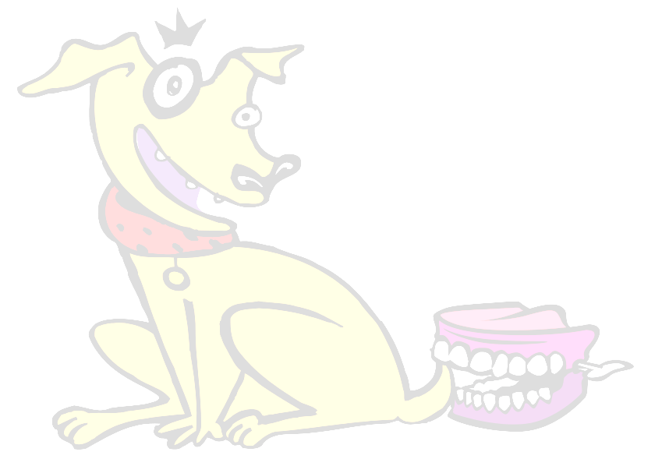
Impact. Does the event affect many people? How will it affect them and for how long?

Discovery. Is there significant new information, previously unknown?

Timeliness. Something just happened or is going to happen very soon.

Proximity. Something that happens close by often attracts more interest than something that is happening far away.

Prominence. People are interested in well-known people, places, events, important dates, and critical situations.

Human interest. A dramatic, personal story has great appeal.

Suspense. People want to know what's going to happen next?

Unusual. Out of the ordinary. Dog bites man is not news. Man bites dog is news.

Conflict. Stories that happen because of opposing needs, points of view, or actions, such as a controversy over voting age.

Progress. Improvements in technology, a new record set, humankind moving forward: All these make news.

Age. A person who does things expected of someone younger or older raises interest.

Humor. People like to laugh. For example, what happens when a player scores a goal for the wrong team?

3. Creating Good Journalism

Good journalism isn’t a mystery. It happens when journalists follow a series of rules and guidelines that have been developed over years.

Use the inverted pyramid. Think of good journalistic writing as taking the shape of an inverted pyramid.

The inverted pyramid puts the most newsworthy information in the first paragraph, often called the lead (see next page). When you begin a story, the lead should contain the 5W1H (the what, who, when, where, why, and how of the story). The remaining information should follow in order of importance.

Headline conveys the
main idea of story.

Lead paragraph contains most
of the who, what, when,
where, why, and how.

Important
and interesting
facts.

Less important
information.

Most Important

Least Important

Be impartial. Unless you are writing an opinion piece, your job is to report facts and the opinions of others. Leave your own opinions out of a news story!

Watch out for long sentences. You don’t need to spend time counting. Just be aware that news-story sentences and paragraphs can be much shorter than what you use when writing, say, an essay.

Check your sources. Where does your information come from? For example, if you get information from the Internet, how can you tell if it is reliable? When possible, use more than one source. The more people you talk to, the better the article. You can use direct quotes or paraphrase what someone says, but always remember to identify who says what.

Useful Terms
5W1H: Information that answers the following questions: Who? What? When? Where? Why? How? Try to answer all these questions briefly in the lead. You can explain them in depth later in the article.

Angle: A particular point of view or way of looking at a subject.

Bias. Slanted. In a news story about a controversial issue, bias results from the absence of an equal or balanced presentation of differing viewpoints.

Editorializing. Introducing your own opinion into a story. Try not to do this unless you are writing an opinion piece!

Fact-checking. Check that your facts are correct. Look up the names of (1) specific people, (2) places, and (3) information you are presenting as fact to be sure you are stating the truth accurately.

Headline. A title or attention grabber above the body of an article.

Lead. The opening of a story, usually a summary of the most important information.

4. How to Conduct an Interview
Getting a good interview at a press conference takes a lot of skill. Here are some tips for getting the most information possible in the least amount of time:

Plan ahead. Write down your interview questions ahead of time. Be sure your questions will help you answer the what, who, when, where, why, and how of the story.

Make contact. Be patient and polite. Ask your questions as clearly and simply as possible.

Keep on track. Some people ramble and change the subject when they talk. Make sure the person answers your question...You may only have one chance!

Take good notes. Make sure you get the facts. Without good notes, you may not be able to remember what was said.

Write down quotes verbatim. Verbatim means “word for word.” Listen for good quotes. Take down quotes verbatim if the person you are interviewing says something:
- More descriptive than you could write.
- In a unique or unusual manner.
- That the reader needs to hear exactly to understand its meaning.

Good Journalism Worksheet

Know good journalism when you read it! Use the news article you have been given and the Inverted Pyramid from the Reporters Handbook to:
1) Look in the news article for the good journalism elements listed below.
2) For each element, answer the questions.

Good Journalism Elements

Headline
Use the headline of the article. Describe the who and what of the story.
Who?

What?

Lead Paragraph
Using the lead paragraph of the article, answer the 5W1H questions listed below.

Who?

What?

Where?

When?

Why?

How?

Good Journalism Worksheet

Impartial
Did the reporter leave his/her opinions out of the story?
If not, what did they say that was partial (expressed an opinion of the reporter)?

Balance
Did the article present different points of view? Name any points of view you found in the article.

Sources
Does the article use facts to tell the story?
List any facts you find in the story.
Summer Journalism Institute is a project of
How does the article describe the source of these facts?

Interviewer: __________________Subject:_______________________

Forming Interview Questions

Choose a topic below and break into pairs. Using the Reporters Handbook—How to Conduct an Interview, write questions to interview each other about one of the following topics:
- Your first day of high school.
- A time you were embarrassed.
- The first time you traveled to another city, state, or country.
- A time you were frustrated or challenged.
- A time you overcame an obstacle.
Be sure your questions will allow you to answer the 5W1H (who, what, when, where, why, how) questions in your story.

Interview Topic: ____________________________________

Questions to ask:

1)

2)

3)

4)

5)

6)

7)

8)

9)

10)

Recording Interview Answers
Interview Topic: ____________________________
Conduct the interview and use this handout to write down notes during the interview. Once the interview is complete, use the Inverted Pyramid in the Reporters Handbook to write a one-paragraph story about the topic you have chosen.

WHAT?

WHO?

WHEN?

WHERE?

WHY?

HOW?

Article Outline Sheet

Using the Reporters Handbook—Creating Good Journalism (Inverted Pyramid), develop an outline for your article.

Headline (Main Idea):

Who?

What?

Lead Paragraph

Who?

What?

Where?

When?

Why?

Supporting Details

Research/Source Log
Using the Reporters Handbook as a guide, conduct preliminary research on the computer. Collect information related to your topic, check its accuracy, and log your sources below. Make sure to write down the Internet address—so you can refer back to the source another time.

Source #1:

Source #2:

Source #3:

Research/Source Log

Source #4

Source #5

Source #6

